Mihai Dan

Textbook 11th Edition

Assignment #2

**Problem #1:**

a. Yes, because the connection from CUSTOMER to PLAN is one to many. It is also optional, so that means the customer has the choice in how many plans to get.

b. No, because no matter the connection between PLAN to CUSTOMER has either a mandatory one or many connections.

c. No, because the PLAN belongs to the CUSTOMER.

d. No, because he has the PLAN must include many HANDSETs.

e. Yes, because the entity HANDSET is not dependent on PLAN.

f. No, each HANDSET must be connected to either one or zero PLANs.

g. Yes, you could draw a connection between HANDSET and OPERATING SYSTEM. The relationship would be <HANDSET> <may> <Use> <any number> <OS>.

h. No, because the relationship between OS and MANUFACTURER goes through the HANDSET TYPE. The company would be able to track the manufacturer through that.

i. Yes, because the OS may be on many HANDSET TYPEs, according to the ER.

j. One states that “one CUSTOMER is responsible for one or more or no PLANs” while the other states that “any amount of PLANs can belong to many customers”.

k. CUSTOMER has a unary relationship with itself. The cardinalities indicate that one or no CUSTOMER is allowed to have more CUSTOMERS (family members).

l. No, because there is no direct connection between HANDSET and CUSTOMER. They are connected through the entity PLAN, and with a multi-customer plan, it is impossible to pick a specific CUSTOMER for HANDSET.

m. No, because the cardinality on the connection between OS and HANDSET TYPE suggests that each HANDSET must have an operating system.

**Problem #23:**

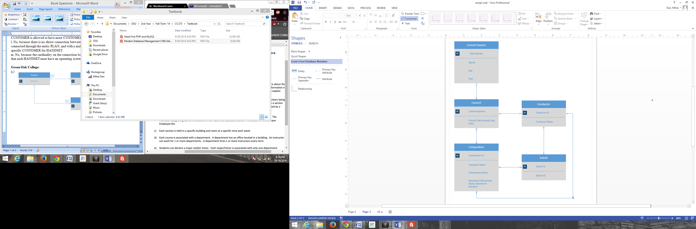

**Business Rule:** Each composition can only have one conductor.

**Green Oak College:**

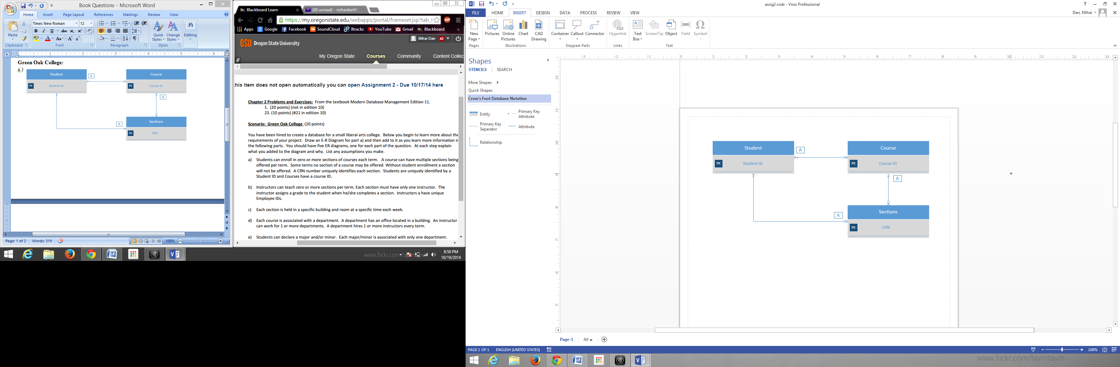a.)

In step a.), I added the entities Student, Course, and Sections, and connected them according to the directions. The A’s indicate an assumption I had made. I assumed that a course must have at least one student in order to exist, a section can be part of only one course, and a student may be part of zero or many sections.

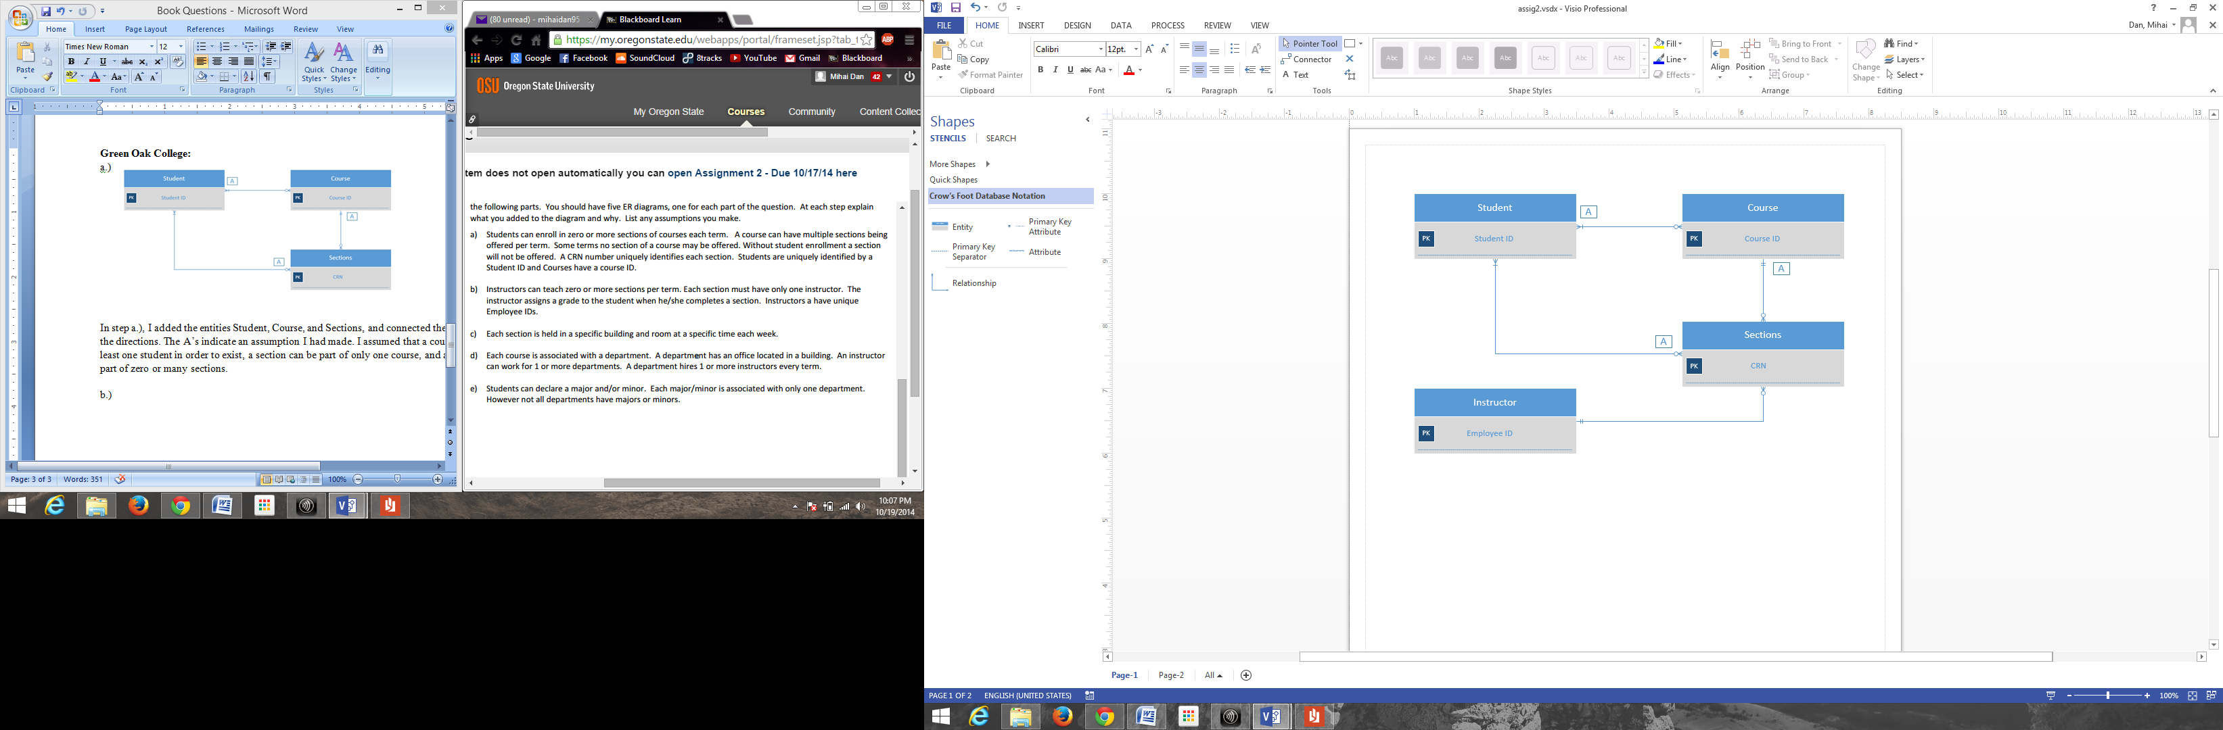

b.)

In step b.), I added the Instructor entity which is connected to the Sections entity.

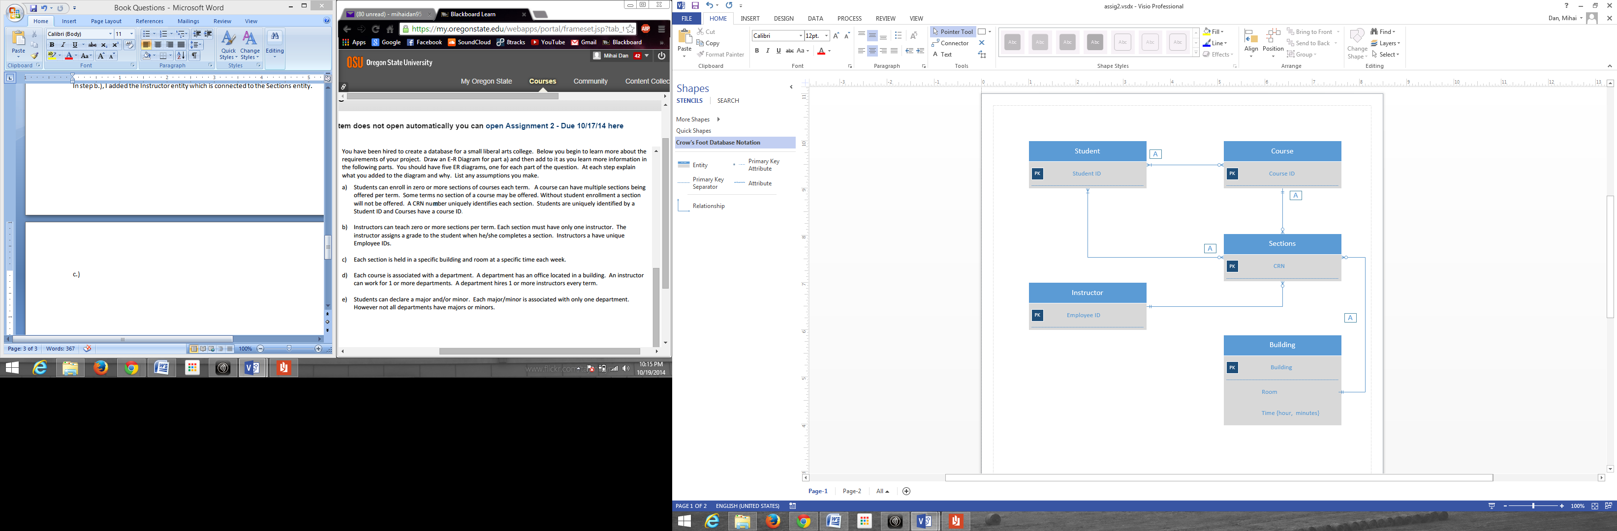c.)

In step c.), I added the entity Building with the attributes room and time. I assumed the connection between Building and Sections. A section can only be in one building, but a building can have zero or more sections within it.

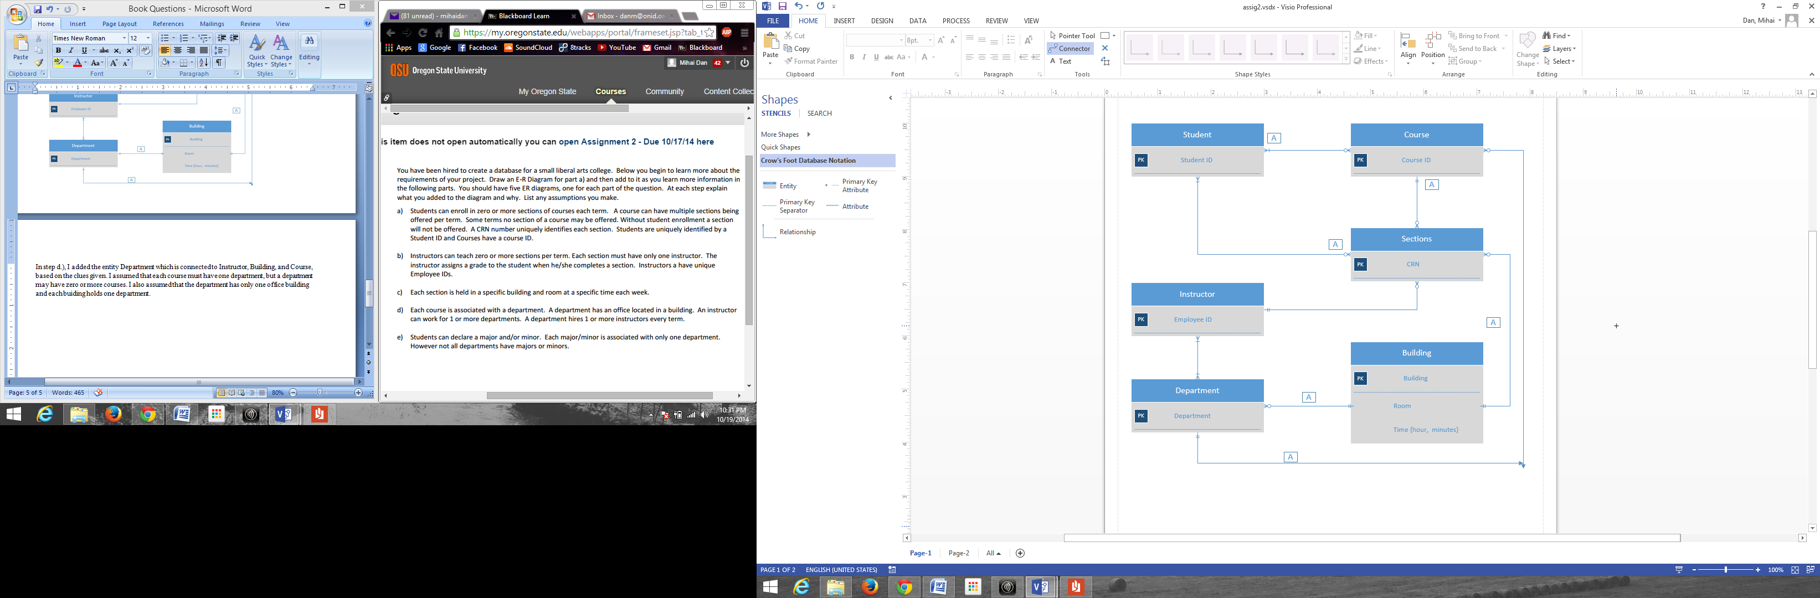

d.)

In step d.), I added the entity Department which is connected to Instructor, Building, and Course, based on the clues given. I assumed that each course must have one department, but a department may have zero or more courses. I also assumed that the department has only one office building and each buiding can hold zero or many departments.

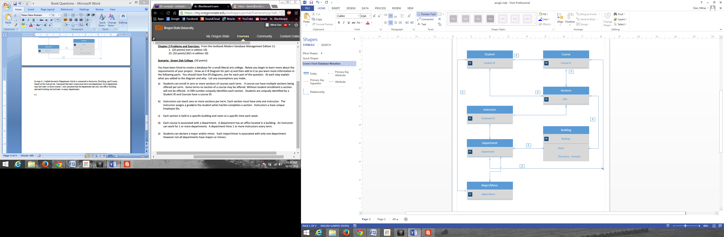

e.)

In the final step, I added the entity Major/Minor. This entity is connected to Department and Student. The connection between Department and Major is given, but I assumed that every student has only one major, but there can be one or more students declared in a major.

*The Partner Proposal was submitted by my partner. I do not have a copy of it.